This guide is for customers who did not bring a hard drive when doing RGH/JTAG, can follow the
following steps and install freestyle easily themselves using following instructions.

Download the needed tools below, and save to your PC.

IMGBurn (Free tool to burn ISO files to CDs/DVDs etc)
http://www.imgburn.com/index.php?act=download

FREESTYLE DASHBOARD
http://www.mediafire.com/?0u4x4tuvireo5d2

Dash Launch Installer
http://www.mediafire.com/?8sugk7gzsskmib0

USB LAUNCH.INI
http://www.mediafire.com/?ar538xre75br5dl

XEXMenu CD Version (Basic starting tool to install stuff)
http://www.mediafire.com/?eaj216qr35cx49r

FAT32 Formatter Tool (format tool for hard drives)
http://www.mediafire.com/?swa72x3uu2rm8na

Xbox Image Browser (ISO extraction tool, to extract XBOX 360 ISOs)
http://www.xbox-scene.com/xbox1data/sep/EFEAZAZVZZYNkgqeUE.php

STEP 1) Setting up external hard drive

• Connect the hard drive to your PC
• Use FAT32 Formatter tool to format the drive to FAT32 file system
FAT32Formatter might require Windows XP Compatibility on Windows 7
• Extract freestyle.rar to external hard drive
• Copy launch.ini to external hard drive
• Extract dash_launch_v2.25.zip to external hard drive
• Make a folder called ‘Games’ on your hard drive.
• CHECK: Hard drive should have 4 items now:
Freestyle folder, dash launch folder, Games folder and launch.ini file

STEP 2) Using XEXMenu to Install Dash Launch

• Burn XEXMenu ISO to a blank CD/DVD using IMGBurn program
• Put the disc in the XBOX 360 and start it
• XEXMenu will load up
• Press left shoulder button twice to access file manager
• Connect your external USB and wait for it to show up in XEXMenu
• Go to dashlaunch folder, and then into Installer folder.
• Start the default.xex file and install dash launch using onscreen instructions
If it asks to update launch.ini, press ‘B’ to skip.
• Dash launch is now installed.
• Start the Xbox 360 console, and freestyle dashboard should load automatically.

STEP 3) Adding games to your harddisk using Xbox Image Browser

To extract the contents of the .ISO, we will use Xbox Image Browser

• Run Xbox Image Browser.exe and select File-->Open Image File

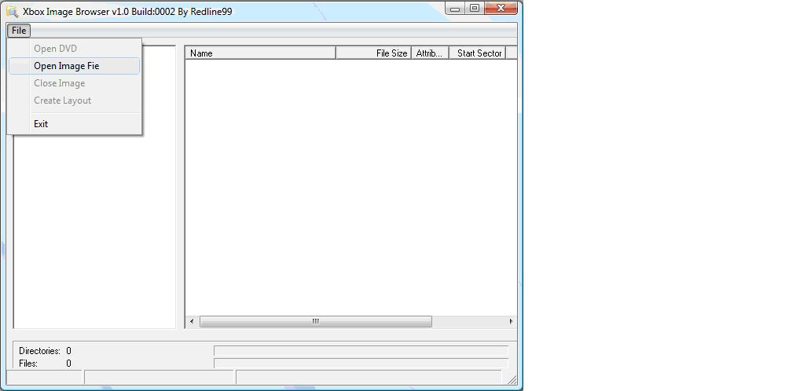

• Select your XBOX 360 .ISO file. For this tutorial, we will use Madden NFL 2010

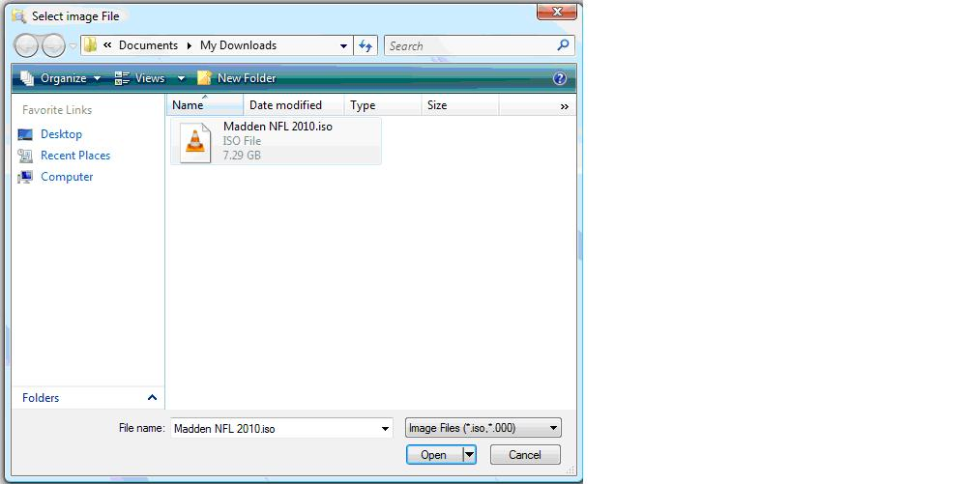

• Right Click on the name of the .ISO and select extract

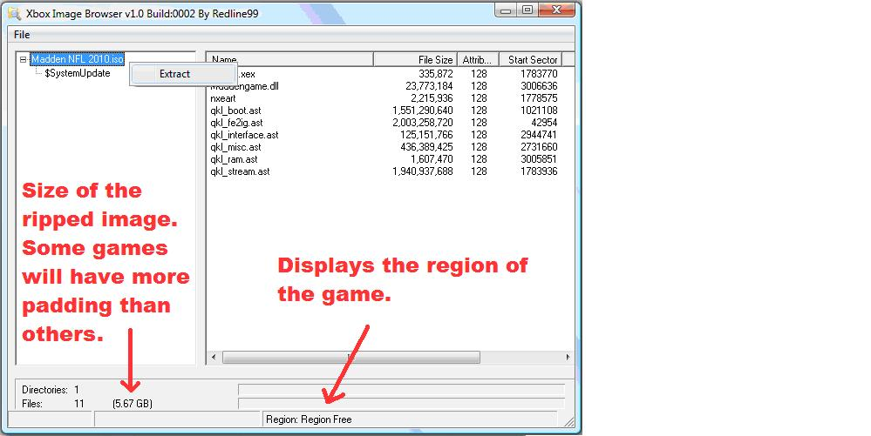

• Create a new folder to place the extracted files in and click OK

STEP 4) Adding games path to freestyle dashboard

• Start Freestyle Dash
• Then Go To " Utilities ", And the " Settings Tab "
• Then Go To " Console Settings "
• Then " Manage Game Paths "
• Then Press "Y" to Add a Folder Path
• Click On " Change Path " Then Locate where your Games are Saved
You would choose USB:/Games in this step.
• Press "Y" When you are INSIDE the Folder where the games are saved
• Press “X" to SAVE the Path you have now added.
• Restart freestyle, go to XBOX360 Games in freestyle dashboard and check

FINISHED!!!

XXXXXXXXXXXXXXXXXXXXXXXXXXXXXXXXXX
OTHER IMPORTANT INFO
XXXXXXXXXXXXXXXXXXXXXXXXXXXXXXXXXX

* If console is using RGH, it can take anywhere 6 to 30 seconds for the console to start if you
have a FAT XBOX 360; Slim consoles can take 10 to 60 seconds to start. If console does not start within this time simply turn off and retry after 15 seconds so that it is discharged.

